A
MINI PROJECT REPORT
on
FRAUD DETECTION IN BANKING DATA USING MACHINE LEARNING
Submitted in partial fulfilment for the award of the degree of
BACHELOR OF TECHNOLOGY
in
ARTIFICIAL INTELLIGENCE AND DATA SCIENCE
By
KISHAN BHASKAR :22Q91A7236
P. SHASHI VARDHAN :22Q91A7243
SRICHARAN SRIRAMOJU :22Q91A7253
VADLA SOWMYASRI :22Q91A7259

Under the guidance of
Mr. Harish Kumar
Assistant Professor, Dept. of AI&DS



DEPARTMENT OF ARTIFICIAL INTELLIGENCE & DATA SCIENCE
MALLA REDDY COLLEGE OF ENGINEERING
(Approved by AICTE-Permanently Affiliated to JNTU-Hyderabad)
Accredited by NBA, Recognized section 2(f) & 12(B) of UGC New Delhi
ISO 9001: 2015 Certified Institution
Maisammaguda, Dhulapally (Post via Kompally), Secunderabad- 500100
2024 - 2025

MALLA REDDY COLLEGE OF ENGINEERING
(Approved by AICTE-Permanently Affiliated to JNTU-Hyderabad)
Accredited by NBA , Recognized section 2(f) & 12(B) of UGC New Delhi
ISO9001:2015 Certified Institution
Maisammaguda, Dhulapally (Post via Kompally), Secunderabad- 500100

DEPARTMENT OF ARTIFICIAL INTELLIGENCE & DATA SCIENCE

CERTIFICATE
This is to certify that the Mini Project report on “Fraud Detection In Banking Data Using Machine Learning” successfully done by the following students of Department of Artificial Intelligence & Data Science of our college in partial fulfilment of the requirement for the award of Bachelor of Technology degree in the year 2024-2025. The results embodied in this report have not been submitted to any other University for the award of any diploma or degree.

KISHAN BHASKAR :22Q91A7236
P.SHASHI VARDHAN :22Q91A7243
SRICHARAN SRIRAMOJU :22Q91A7253
VADLA SOWMYA SRI :22Q91A7259
Submitted for the viva voice examination held on:

INTERNAL GUIDE PROJECT COORDINATOR HOD
Mr. Harish Kumar Mrs. D. Kranthi Deep Dr. J. Britto
Assistant Professor Assistant Professor Professor&Head

Internal Examiner External Examiner

DECLARATION
2

We, Kishan Bhaskar, P. Shashi Vardhan, Sricharan Sriramoju, Vadla Sowmya Sri with Regd.no. 22Q91A7236, 22Q91A7243, 22Q91A7253, 22Q91A7259 are hereby declaring that the mini project entitled “FRAUD DETECTION IN BANKING DATA USING MACHINE LEARNING” has done by us under the guidance of Mr. Harish Kumar, Assistant Professor, Department of Artificial Intelligence & Data Science is submitted in the partial fulfilment of the requirements for the award of degree of BACHELOR OF TECHNOLOGY in ARTIFICIAL INTELLIGENCE & DATA SCIENCE. The Result embedded in this project report have not been submitted to any University or institute for the award of any degree.

Signatures of the Candidate
KISHAN BHASKAR :22Q91A7236
P.SHASHI VARDHAN :22Q91A7243
SRICHARAN SRIRAMOJU :22Q91A7253
VADLA SOWMYA SRI :22Q91A7259

DATE:
PLACE: Maisammaguda

ACKNOWLEDGEMENT

First and foremost, we would like to express our immense gratitude towards our institution Malla Reddy College of Engineering, which helped us to attain profound technical skills in the field of Computer Science & Engineering, there by fulfilling our most cherished goal.

We are pleased to thank SRI CH. Malla Reddy, our Founder Chairman MRGI, Sri Ch. Mahender Reddy, Secretary, MRGI for providing this opportunity and support throughout the course.

It gives us immense pleasure to acknowledge the perennial inspiration of DR. M. Ashok our beloved principal for his kind co-operation and encouragement in bringing out this task.

We would like to thank, DR.J. Gladson Maria Britto HOD, AI & DS Department for their inspiration adroit guidance and constructive criticism for successful completion of our degree.

We would like to thank Mrs. D. Kranthi Deep Assistant professor, Our project Coordinator and
Mr. Harish Kumar Assistant Professor, our internal guide for their valuable suggestions and guidance during the exhibition and completion of this project.

Finally, we avail this opportunity to express our deep gratitude to all staff who have contribute their valuable assistance and support making our project success.

KISHAN BHASKAR :22Q91A7236
P.SHASHI VARDHAN :22Q91A7243
SRICHARAN SRIRAMOJU :22Q91A7253
VADLA SOWMYA SRI :22Q91A7259

FRAUD DETECTION IN BANKING DATA USING MACHINE LEARNING

TABLE OF CONTENTS

CHAPTER NUMBER | CONTENT | PAGE NUMBER
A | ABSTARCT | I
B | LIST OF ABBREVIATIONS | II
C | LIST OF FIGURES | III
D | LIST OF SCREENS | IV
1 | CHAPTER 1-INTRODUCTION  - INTRODUCTION  - OBJECTIVE  - EXISTING SYSTEM  1.3.1EXISTING SYSTEM DISADVANTAGES  - PROPOSED SYSTEM  1.4.1PROPOSED SYSTEM DISADVANTAGES | 1  1  2  4  4  4  4
2 | CHAPTER 2- LITERATURE SURVEY  2.1 LITERATURE SURVEY | 5  6
3 | CHAPTER 3- SYSTEM ANALYSIS  3.1 HARDWARE REQUIREMENTS  3.2 SOFTWARE REQUIREMENTS | 8  9  9
4 | CHAPTER 4- SYSTEM STUDY, SYSTEM  DESIGN & ARCHITECTURE  4.1 FEASIBILITY STUDY  4.1.1 ECONOMICAL FEASIBILITY  4.1.2 TECHNICAL FEASIBILITY  4.1.3 OPERATIONAL FEASIBILITY  4.2 SYSTEM DESIGN  4.2.1 USE CASE DIAGRAM  4.2.2 CLASS DIAGRAM  4.2.3 SEQUENCE DIAGRAM  4.2.4 COLLABORATION DIAGRAM  4.2.5 COMPONENT DIAGRAM  4.2.6 DEPLOYMENT DIAGRAM  4.2.7 ACTIVITY DIAGRAM  4.2.8 DATA FLOW DIAGRAM  4.3 ARCHITECTURE | 10  11  11  12  12  13  13  14  15  16  16  17  18  19  20
5 | CHAPTER 5: DEVELOPMENT TOOLS  5.1 PYTHON  5.1.1 KEY FEATURES  5.2 INSTALLATION  5.3 PYTHON GUI (TKINTER)  5.4 PYTHON IDLE  5.5 LIBRARIES  5.6 ALGORITHM | 21  22  22  22  23  23  24  29
6 | CHAPTER 6: IMPLEMENTATION  6.1 SAMPLE CODE | 37  38
7 | CHAPTER 7: TESTING  7.1 SYSTEM TESTING  7.2 MODULE TESTING  7.3 INTEGRATION TESTING  7.4 ACCEPTANCE TESTING | 47  48  48  48  49
8 | CHAPTER 8: RESULT  8.1 RESULTS | 51  52
9 | CHAPTER 9: CONCLUSION  9.1 CONCLUSION | 57  58
10 | CHAPTER 10: FUTURE ENHANCEMENTS  10.1 FUTURE ENHANCEMENTS | 59  60
11 | CHAPTER 11: REFERENCE  11.1 REFERENCES | 61  62

ABSTRACT

As technology advanced and e-commerce services expanded, credit cards became one of the most popular payment methods, resulting in an increase in the volume of banking transactions. Furthermore, the significant increase in fraud requires high banking transaction costs. As a result, detecting fraudulent activities has become a fascinating topic. In this study, we consider the use of class weight-tuning hyperparameters to control the weight of fraudulent and legitimate transactions. We use Bayesian optimization in particular to optimize the hyperparameters while preserving practical issues such as unbalanced data. We propose weight-tuning as a pre-process for unbalanced data, as well as CatBoost and XGBoost to improve the performance of the LightGBM method by accounting for the voting mechanism. Finally, in order to improve performance even further, we use deep learning to fine-tune the hyperparameters, particularly our proposed weight-tuning one. We perform some experiments on real-world data to test the proposed methods. To better cover unbalanced datasets, we use recall-precision metrics in addition to the standard ROC-AUC. CatBoost, LightGBM, and XGBoost are evaluated separately using a 5-fold cross-validation method.

LIST OF ABBREVIATIONS

SERIAL NUMBER | ACROYNM | DESCRIPTION
01 | ADABOOST | Adaptive Boosting
02 | XGBOOST | Extreme Gradient Boosting
03 | ROC-AUC | Receiver Characteristic Area Under The Curve
04 | LightGBM | Light Gradient Boosting Machine
05 | CATBOOST | Categorical Boosting
06 | SVM | Support Vector Machine
07 | MLP | Multi Layer Perceptron
08 | DNN | Deep Neural Network
09 | MCC | Matthews Corelation Coefficient

LIST OF FIGURES

FIGURE NUMBER | NAME OF THE FIGURE | PAGE NUMBER
4.2.1 | USE CASE DIAGRAM | 13
4.2.2 | CLASS DIAGRAM | 14
4.2.3 | SEQUENCE DIAGRAM | 15
4.2.4 | COLLABORATION DIAGRAM | 16
4.2.5 | COMPONENT DIAGRAM | 17
4.2.6 | DEPLOYMENT DIAGRAM | 18
4.2.7 | ACTIVITY DIAGRAM | 19
4.2.8 | DATA FLOW DIAGRAM | 20
4.3 | ARCHITECTURE | 20

LIST OF SCREENS

FIGURE NUMBER | NAME OF THE SCREEN | PAGE NUMBER
8.1.1 | TEST DATASET | 52
8.1.2 | DATASET VALUES | 52
8.1.3 | UPLOAD AND PREPROCESS DATA | 53
8.1.4 | UPLOAD DATA | 53
8.1.5 | LOGISTIC REGRESSION ALGORITHM | 54
8.1.6 | MLP & NAÏVE BAYES ALGORITHM | 54
8.1.7 | DECISION TREE & SVM ALGORITHM | 55
8.1.8 | RANDOM FOREST & DNN ALGORITHM | 55
8.1.9 | COMPARSION GRAPH | 56

CHAPTER 01
INTRODUCTION

1.1 INTRODUCTION
In recent years, there has been a significant increase in the volume of financial transactions due to the expansion of financial institutions and the popularity of web-based e-commerce. Fraudulent transactions have become a growing problem in online banking, and fraud detection has always been challenging. Along with credit card development, the pattern of credit card fraud has always been updated. Fraudsters do their best to make it look legitimate, and credit card fraud has always been updated. Fraudsters do their best to make it look the associate editor coordinating the review of this manuscript and approving it for publication was Zhan Bu . legitimate. They try to learn how fraud detection systems work and continue to stimulate these systems, making fraud detection more complicated. Therefore, researchers are constantly trying to find new ways or improve the performance of the existing methods. People who commit fraud usually use security, control, and monitoring weaknesses in commercial applications to achieve their goals. However, technology can be a tool to combat fraud . To prevent further possible fraud, it is important to detect the fraud right away after its occurrence. Fraud can be defined as wrongful or criminal deception intended to result in financial or personal gain. Credit card fraud is related to the illegal use of credit card information In digital transactions, fraud can happen over the line or the web, since the cardholders usually provide the card number, expiration date, and card verification number by telephone or website. There are two mechanisms, fraud prevention and fraud detection, that can be exploited to avoid fraud-related losses. Fraud prevention is a proactive method that stops fraud from happening in the first place. On the other hand, fraud detection is needed when a fraudster attempts a fraudulent transaction. Fraud detection in banking is considered a binary classification problem in which data is classified as legitimate or fraudulent. Because banking data is large in volume and with datasets containing a large amount of transaction data, manually reviewing and finding patterns for fraudulent transactions is either impossible or takes a long time. Therefore, machine learning-based algorithms play a pivotal role in fraud detection and prediction. Machine learning algorithms and high processing power increase the capability of handling large datasets and fraud detection in a more efficient manner. Machine learning algorithms and deep learning also provide fast and efficient solutions to real-time problems. In this paper, we propose an efficient approach for detecting credit card fraud that has been evaluated on publicly available datasets and has used optimised algorithms LightGBM, XGBoost, CatBoost, and logistic regression individually, as well as majority voting combined methods, as well as deep learning and hyperparameter settings. An ideal fraud detection system should detect more fraudulent cases, and the precision of detecting fraudulent cases should be high, i.e., all results should be correctly detected, which will lead to the trust of customers in the bank, and on the other hand, the bank will not suffer losses due to incorrect detection.

1.2 OBJECTIVE:
As technology advanced and e-commerce services expanded, credit cards became one of the most popular payment methods, resulting in an increase in the volume of banking transactions. Furthermore, the significant increase in fraud requires high banking transaction costs. As a result, detecting fraudulent activities has become a fascinating topic. In this study, we consider the use of class weight-tuning hyperparameters to control the weight of fraudulent and legitimate transactions. We use Bayesian optimization in particular to optimize the hyperparameters while preserving practical issues such as unbalanced data. We propose weight-tuning as a pre-process for unbalanced data, as well as CatBoost and XGBoost to improve the performance of the LightGBM method by accounting for the voting mechanism. Finally, in order to improve performance even further, we use deep learning to fine-tune the hyperparameters, particularly our proposed weight-tuning one. We perform some experiments on real-world data to test the proposed methods. To better cover unbalanced datasets, we use recall-precision metrics in addition to the standard ROC-AUC. CatBoost, LightGBM, and XGBoost are evaluated separately using a 5-fold cross-validation method. Furthermore, the majority voting ensemble learning method is used to assess the performance of the combined algorithms. LightGBM and XGBoost achieve the best level criteria of ROC-AUC = 0.95, precision 0.79, recall 0.80, F1 score 0.79, and MCC 0.79, according to the results. By using deep learning and the Bayesian optimization method to tune the hyperparameters, we also meet the ROC-AUC = 0.94, precision = 0.80, recall = 0.82, F1 score = 0.81, and MCC = 0.81. This is a significant improvement over the cutting-edge methods we compared it to.

1.3 EXISTING SYSTEM:
The problem of detecting fraudulent transactions is being studied for a long time. Fraudulent transactions are harmful to the economy and discourage people from investing in bitcoins or even trusting other block chain-based solutions. Fraudulent transactions are usually suspicious either in terms of participants involved in the transaction or the nature of the transaction. Members of a block chain network want to detect Fraudulent transactions as soon as possible to prevent them from harming the block chain network’s community and integrity.
1.3.1 EXISTING SYSTEM DISADVANTAGES:
    - Reduced accuracy
    - Privacy concerns
    - Complexity

  - PROPOSED SYSTEM:
Many Machine Learning techniques have been proposed to deal with this problem, some results appear to be quite promising , but there is no obvious superior method. This paper compares the performance of various supervised machine learning models like SVM, Decision Tree, Naive Bayes, Logistic Regression, and few deep learning models in detecting fraudulent transactions in a blockchain network. Such comparative study will help decide the best algorithm based on accuracy and computational speed trade-off. Our goal is to see which users and transactions have the highest probability of being involved in fraudulent transactions.
1.4.1 PROPOSED SYSTEM ADVANTAGES:
    - Improved accuracy
    - Enhanced privacy
    - Scalability

CHAPTER 02
LITERATURE SURVEY

2.1 LITERATURE SURVEY

1.Title: A blockchain based framework for fraud detection.
Authors: Joshi, P. Kumar Year: 2019.
Abstract:
Corruption or frauds has become common terms which are associated with government bodies working across the globe. It often leads to several social and economic problems, if remain unchecked. Increase in the rate of corruption adversely affects the development of any country. The government funds or money which is intended for the welfare of the public goes in the pocket of greedy officers. This research work is aimed to reduce corruption or frauds using blockchain technology. To establish our framework, we have worked on a generic scenario in which a government has various schemes running for the welfare of common people and the funds are disbursed through a layered architecture of government passing through various organizations. Non-transparency, poor management of government records, delay in verification process can lead to corruption in various schemes at various levels. Blockchain being a transparent, immutable and decentralized mechanism is found to be a mightier technology which can help fighting corruption in the experimental generic scenario.

2.Title: Fraud detections for online businesses: a perspective from blockchain technology.
Authors: Cai Y, Zhu D Year: 2016.
Abstract:
The reputation system has been designed as an effective mechanism to reduce risks associated with online shopping for customers. However, it is vulnerable to rating fraud. Some raters may inject unfairly high or low ratings to the system so as to promote their own products or demote their competitors.

3.Title: Video Fraud Detection using Blockchain.
Authors: Dhiran, A. Kumar Year: 2020.
Abstract:
This paper has considered the problem of Video Fraudulence, i.e., attackers can tamper with the original video and can create a fake video of their own. This problem is of great practical importance given the massive volume of online videos available through the World Wide Web, Internet news feeds, electronic mail, corporate databases, and digital libraries. To the best of our knowledge, no such video fraud detection algorithm has been proposed in the literature that can detect, using Blockchain, whether the video has been tampered with. This paper is a comparative study and provides a prototype of how it applies Blockchain to detect video fraudulence. The focus is on the usability of Blockchain and how to implement it to get the desired result. Three features of Blockchain that are Decentralization, Data transparency, and Security and privacy are being used to provide a reliable solution. Some cryptographic algorithms are used to find unique feature in all of the videos that can act as the hash value of the video because, in Blockchains, every node stores the data in the form of the hash value. If the video is tampered with, then the hash value changes and hence any fraud in the video can be detected.

CHAPTER 03
SYSTEM ANALYSIS

3.1 HARDWARE REQUIREMENTS:
- System : Intel I3
- Hard Disk : 500 GB.
- Speed : 1.1 GHz.
- Ram : 16 GB.
- Key Board : Standard Windows Keyboard
- Mouse : Two or Three Button Mouse.
- Monitor : SVGA.

3.2 SOFTWARE REQUIREMENTS:
- Operating System : Windows 10(min)
- Coding Language : Python 3.7.0
- Framework : Tensorflow
- Libraries : sklearn

CHAPTER 04
SYSTEM STUDY, SYSTEM DESIGN & ARCHITECTURE

4.1 FEASIBILITY STUDY
The main objective of the feasibility study is to test the Technical, Operational and Economical feasibility for adding new modules and debugging old running system. All system is feasible if they are unlimited resources and infinite time. There are aspects in the feasibility study portion of the preliminary investigation.
Three key considerations involved in the feasibility analysis are
▪ ECONOMICAL FEASIBILITY
▪ TECHNICAL FEASIBILITY
▪ OPERATIONAL FEASIBILITY

4.1.1 ECONOMICAL FEASIBILITY
A system can be developed technically and that will be used if installed must still be a good investment for the organization. In the economic feasibility, the development cost in creating the system is evaluated against the ultimate benefit derived from the new systems. Financial benefits must equal or exceed the costs. The system is economically feasible. It does not require any addition hardware or software. Since the interface for this system is developed using the existing resources and technologies available at NIC, there is nominal expenditure and economic feasibility for certain.

4.1.2 TECHNICAL FEASIBILITY
Earlier no system existed to cater to the needs of ‘Secure Infrastructure Implementation System’. The current system developed is technically feasible. It is a web-based user interface for audit workflow at NIC-CSD. Thus, it provides an easy access to. the users. The database’s purpose is to create, establish and maintain a workflow among various entities in order to facilitate all concerned users in their various capacities or roles. Permission to the users would be granted based on the roles specified. Therefore, it provides the technical guarantee of accuracy, reliability and security.

4.1.3 OPERATIONAL FEASIBILITY
Proposed projects are beneficial only if they can be turned out into information system. That will meet the organization’s operating requirements. Operational feasibility aspects of the project are to be taken as an important part of the project implementation. This system is targeted to be in accordance with the above-mentioned issues. Beforehand, the management issues and user requirements have been taken into consideration. So, there is no question of resistance from the users that can undermine the possible application benefits. The well-planned design would ensure the optimal utilization of the computer resources and would help in the improvement of performance status.
4.2 SYSTEM DESIGN

4.2.1 USE CASE DIAGRAM

A use case diagram at its simplest is a representation of a user's interaction with the system and depicting the specifications of a use case. A use case diagram can portray the different types of users of a system and the various ways that they interact with the system. This type of diagram is typically used in conjunction with the textual use case and will often be accompanied by other types of diagrams as well.

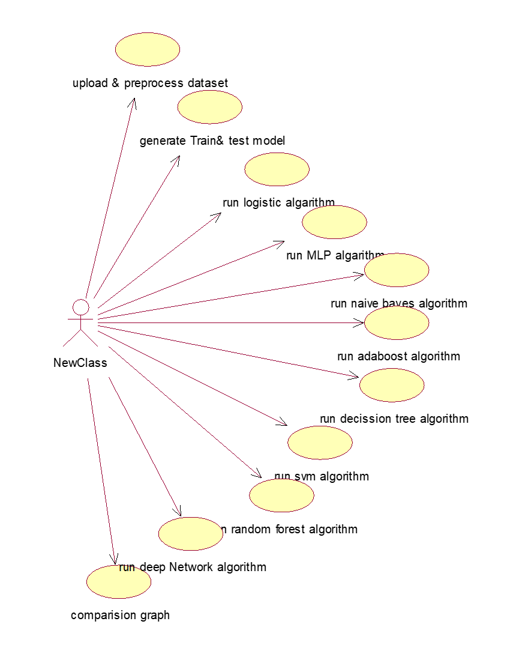
Fig 4.2.1 use case diagram

4.2.2 CLASS DIAGRAM
The class diagram is the main building block of object-oriented modeling. It is used both for general conceptual modeling of the systematic of the application, and for detailed modeling translating the models into programming code. Class diagrams can also be used for data modeling. The classes in a class diagram represent both the main objects, interactions in the application and the classes to be programmed. In the diagram, classes are represented with boxes which contain three parts:
- The upper part holds the name of the class
- The middle part contains the attributes of the class
- The bottom part gives the methods or operations the class can take or undertake
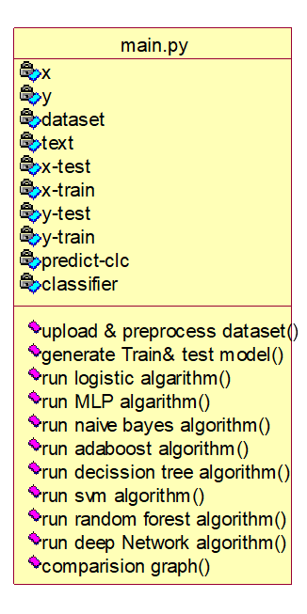
Fig 4.2.2 class diagram

4.2.3 SEQUENCE DIAGRAM

A sequence diagram is a kind of interaction diagram that shows how processes operate with one another and in what order. It is a construct of a Message Sequence Chart. A sequence diagram shows object interactions arranged in time sequence. It depicts the objects and classes involved in the scenario and the sequence of messages exchanged between the objects needed to carry out the functionality of the scenario. Sequence diagrams are typically associated with use case realizations in the Logical View of the system under development. Sequence diagrams are sometimes called event diagrams, event scenarios, and timing diagrams.
Fig 4.2.3 sequence diagram

4.2.4 COLLABORATION DIAGRAM

A collaboration diagram describes interactions among objects in terms of sequenced messages. Collaboration diagrams represent a combination of information taken from class, sequence, and use case diagrams describing both the static structure and dynamic behavior of a system.
fig 4.2.4 collaboration diagram

4.2.5 COMPONENT DIAGRAM

In the Unified Modelling Language, a component diagram depicts how components are wired together to form larger components and or software systems. They are used to illustrate the structure of arbitrarily complex systems.
Components are wired together by using an assembly connector to connect the required interface of one component with the provided interface of another component. This illustrates the service consumer - service provider relationship between the two components.

fig 4.2.5 component diagram

4.2.6 DEPLOYMENT DIAGRAM

A deployment diagram in the Unified Modeling Language models the physical deployment of artifacts on nodes. To describe a web site, for example, a deployment diagram would show what hardware components ("nodes") exist (e.g., a web server, an application server, and a database server), what software components ("artifacts") run on each node (e.g., web application, database), and how the different pieces are connected (e.g., JDBC, REST, RMI).The nodes appear as boxes, and the artifacts allocated to each node appear as rectangles within the boxes. Nodes may have sub nodes, which appear as nested boxes. A single node in a deployment diagram may conceptually represent multiple physical nodes, such as a cluster of database servers.

fig 4.2.6 deployment diagram

4.2.7 ACTIVITY DIAGRAM

Activity diagram is another important diagram in UML to describe dynamic aspects of the system. It is basically a flow chart to represent the flow form one activity to another activity. The activity can be described as an operation of the system. So, control flow is drawn from one operation to another. This flow can be sequential,branched or concurrent.
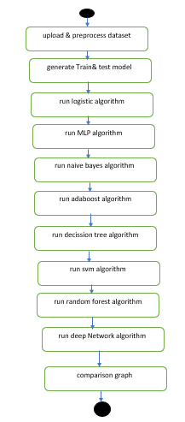
fig 4.2.7 activity diagram

4.2.8 DATA FLOW DIAGRAM
Data flow diagrams illustrate how data is processed by a system in terms of inputs and outputs. Data flow diagrams can be used to provide a clear representation of any business function. The technique starts with an overall picture of the business and continues by analyzing each of the functional areas of interest. This analysis can be carried out in precisely the level of detail required. The technique exploits a method called top-down expansion to conduct the analysis in a targeted way. As the name suggests, Data Flow Diagram (DFD) is an illustration that explicates the passage of information in a process. A DFD can be easily drawn using simple symbols. Additionally, complicated processes can be easily automated by creating DFDs using easy-to-use, free downloadable diagramming tools. A DFD is a model for constructing and analyzing information processes. DFD illustrates the flow of information in a process depending upon the inputs and outputs. A DFD can also be referred to as a Process Model. A DFD demonstrates business or technical process with the support of the outside data saved, plus the data flowing from the process to another and the end results
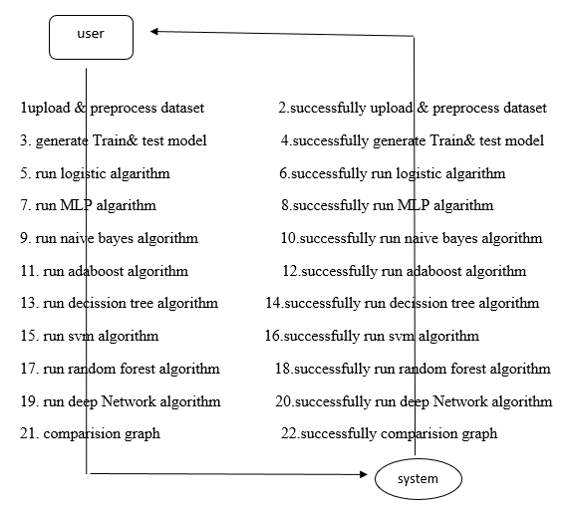
Fig 4.2.8. dataflow diagram

4.3 SYSTEM ARCHITECTURE
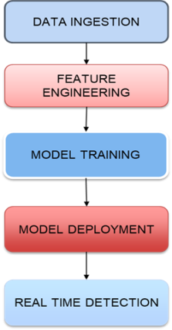
fig 4.3 system architecture

CHAPTER 05
DEVELOPMENT TOOLS

5.1 PYTHON
One of the most popular languages is Python. Guido van Rossum released this language in 1991. Python is available on the Mac, Windows, and Raspberry Pi operating systems. The syntax of Python is simple and identical to that of English. When compared to Python, it was seen that the other language requires a few extra lines. It is an interpreter-based language because code may be run line by line after it has been written. This implies that rapid prototyping is possible across all platforms. Python is a big language with a free, binary- distributed interpreter standard library. It is inferior to maintenance that is conducted and is straightforward to learn. It is an object-oriented, interpreted programming language. It supports several different programming paradigms in addition to object-oriented programming, including functional and procedural programming.
5.1.1 KEY FEATURES
1) Easy: Because Python is a more accessible and straightforward language, Python programming is easier to learn.
2) Interpreted language: Python is an interpreted language, therefore it can be used to examine the code line by line and provide results.
3) Open Source: Python is a free online programming language since it is open-source.
4) Portable: Python is portable because the same code may be used on several computer standard
5) Libraries: Python offers a sizable library that we may utilize to create
applications quickly.
6) GUI: It stands for GUI (Graphical User Interface)
7) Dynamical typed: Python is a dynamically typed language, therefore the type of the value will be determined at runtime.

5.2 INSTALLATION
To install Python on your computer, follow these basic steps:
• Step 1: Visit the Python website Go to the official Python website at
https://www.python.org/.
• Step 2: Select the operating system Choose the appropriate installer for your operating system. Python supports Windows, macOS, and various Linux distributions. Make sure to select the correct version that matches your operating system.
• Step 3: Check which version of Python is installed; if the 3.7.0 version is not there, uninstall it through the control panel and
• Step 4: Install Python 3.7.0 using Cmd.
• Step 5: Install the all libraries that required to run the project
• Step 6: Run

5.3 PYTHON GUI (TKINTER)
• Python provides a wide range of options for GUI development (Graphical User Interfaces).
• Tkinter, the most widely used GUI technique, is used for all of them.
• The Tk GUI toolkit offered by Python is used with the conventional Python interface.
• Python and Tkinter together give a straightforward and quick way. The Tk GUI toolkit's object-oriented user interface is called Tkinter.
Making a GUI application is easy using Tkinter. Following are the steps:
1) Install the Tkinter module in place.
2) The GUI application, Makes the primary window
3) Include one or more of the widgets mentioned above in the GUI application.
4) Set up the main event loop such that it reacts to each user-initiated event.
Although Tkinter is the only GUI framework included in the Python standard library, Python includes a GUI framework. The default library for Python is called Tkinter. Tk is a scripting language often used in designing, testing, and developing GUIs. Tk is a free, open-source
widget toolkit that may be used to build GUI applications in a wide range of computer languages.

5.4 PYTHON IDLE
❖ Python IDLE offers a full-fledged file editor, which gives you the ability to write and execute Python programs from within this program. The built-in file editor also includes several features, like code completion and automatic indentation, that will speed up your coding workflow.
❖ Guido Van Rossum named Python after the British comedy group Monty Python while the name IDLE was chosen to pay tribute to Eric Idle, who was one of the Monty Python's founding members. IDLE comes bundled with the default implementation of the Python language since the 01.5. 2b1 release When you install Python, IDLE is typically installed along with it.
• Editor: IDLE includes a text editor where you can write your Python code. It offers syntax highlighting, automatic indentation, and code completion to enhance your coding experience.
• Interactive Shell: The Python shell in IDLE allows you to execute Python code interactively. You can type commands, statements, or function calls directly in the shell, and Python will execute them immediately.
• Debugging: IDLE provides basic debugging capabilities to help you find and fix errors in your code. You can set breakpoints, step through code, inspect variables, and track the program's execution.
• Python Help: IDLE provides access to the Python documentation and built-in help. You can access the help menu to find information about Python modules, functions, classes, and more.
• Script Execution: In addition to the interactive shell, IDLE allows you to run Python scripts stored in files. You can write your code in the editor and execute it as a script to see the output or interact with the program.
• Customization: IDLE can be customized to suit your preferences. You can modify settings related to syntax highlighting, indentation, fonts, and more.
• Python IDLE serves as a beginner-friendly development environment and learning tool. It is suitable for writing small scripts, testing code snippets, experimenting with Python features, and learning the language's basics. However, for more advanced development projects, you may consider using other code editors or integrated development environments (IDEs) that provide additional features and better project management capabilities.

5.5 LIBRARIES
In Python, libraries (also referred to as modules or packages) are collections of pre-written code that provide additional functionality and tools to extend the capabilities of the Python language. Libraries contain reusable code that developers can leverage to perform specific tasks without having to write everything from scratch. Python libraries are designed to solve common problems, such as handling data, performing
mathematical operations, interacting with databases, working with files, implementing networking protocols, creating graphical user interfaces (GUIs), and much more. They provide ready-to-use functions, classes, and methods that simplify complex operations and save development time. Libraries in Python offer various advantages:
▪ Code Reusability:
▪ Efficiency:
▪ Collaboration
▪ Domain-Specific Functionality
▪ To use a Python library, you need to install it first.
There are some libraries following:
➢ Pandas: Pandas are a Python computer language library for data analysis and manipulation. It offers a specific operation and data format for handling time series and numerical tables. It differs significantly from the release3-clause of the BSD license. It is a well-liked open-source of opinion that is utilized in machine learning and data analysis.
▪ It has functions for analysing, cleaning, exploring, and manipulating data.
▪ The name "Pandas" has a reference to both "Panel Data", and "Python Data Analysis” and was created by Wes McKinney in 2008.
▪ Pandas allow us to analyse big data and make conclusions based on statistical theories.
▪ Pandas can clean messy data sets, and make them readable and relevant.
➢ NumPy: The NumPy Python library for multi-dimensional, big-scale matrices adds a huge number of high-level mathematical functions. It is possible to modify NumPy by utilizing a Python library. Along with line, algebra, and the Fourier transform operations, it also contains several
matrices-related functions.
▪ NumPy is a Python library used for working with arrays.
▪ It also has functions for working in domain of linear algebra, Fourier transform, and matrices.
▪ NumPy was created in 2005 by Travis Oliphant. It is an open source project and you can use it freely.
▪ NumPy stands for Numerical Python.
▪ In Python we have lists that serve the purpose of arrays, but they are slow to process.
▪ NumPy aims to provide an array object that is up to 50x faster than traditional Python lists.
➢ Matplotlib: It is a multi-platform, array-based data visualization framework built to interact with the whole SciPy stack. MATLAB is proposed as an open-source alternative. Matplotlib is a Python extension and a cross-platform toolkit for graphical plotting and visualization. Matplotlib is a popular Python library for creating static, animated, and interactive visualizations. It provides a flexible and comprehensive set of tools for generating plots, charts, histograms, scatter plots, and more. Matplotlib is widely used in various fields, including data analysis, scientific research, and data visualization. Here are some key features and functionalities of the Matplotlib library:
▪ Plotting Functions
▪ Customization Options
▪ Multiple Interfaces
▪ Integration with NumPy and pandas
▪ Subplots and Figures:
➢ Scikit-learn: The most stable and practical machine learning library for Python is scikit-learn. Regression, dimensionality reduction, classification, and clustering are just a few of the helpful tools it provides through the Python interface for statistical modeling and machine learning. It is an essential part of the Python machine learning toolbox used by JP Morgan. It is frequently used in various machine learning applications, including classification and predictive analysis. Scikit-learn (also referred to as sklearn) is a widely used open-source machine learning library for Python. It provides a comprehensive set of tools and algorithms for various machine learning tasks, including classification, regression, clustering, dimensionality reduction, model selection, and pre-processing. Here are some key features and functionalities of the Scikit-learn library:
▪ Easy-to-Use Interface:
▪ Broad Range of Algorithms:
▪ Data Pre-processing and Feature Engineering:
▪ Model Evaluation and Validation:
▪ Integration with NumPy and pandas:
▪ Robust Documentation and Community Support:
➢ Keras: * Google's Keras is a cutting-edge deep learning API for creating neural networks. It is created in Python and is designed to simplify the development of neural networks. Additionally, it enables the use of various neural networks for computation. Deep learning models are developed and tested using the free and open-source Python software known as Keras. Keras is a high-level deep learning library for Python. It is designed to provide a user-friendly and intuitive interface for building and training deep learning models. Keras acts as a front-end API, allowing developers to define and configure neural networks while leveraging the computational backend engines, such as Tensor Flow or Theano. Here are some key features and functionalities of the Keras library:
▪ User-Friendly API
▪ Multi-backend Support
▪ Wide Range of Neural Network Architectures
▪ Pre-trained Models and Transfer Learning
▪ Easy Model Training and Evaluation
➢ h5py: * The h5py Python module offers an interface for the binary HDF5 data format. Thanks to p5py, the top can quickly halt the vast amount of numerical data and alter it using the NumPy library. It employs common syntax for Python, NumPy, and dictionary arrays. h5py is a Python library that provides a simple and efficient interface for working with datasets and files in the Hierarchical Data Format 5 (HDF5) format. HDF5 is a versatile data format commonly used for storing and managing large volumes of numerical data. Here are some key features and functionalities of the h5py library:
▪ HDF5 File Access
▪ Dataset Handling:
▪ Group Organization:
▪ Attributes:
▪ Compatibility with NumPy
▪ Performance
➢ Tensor flow: TensorFlow is a Python library for fast numerical computing created and released by Google. It is a foundation library that can be used to create Deep Learning models directly or by using wrapper libraries that simplify the process built on top of TensorFlow. TensorFlow is an end-to-end open source platform for machine learning. TensorFlow is a rich system for managing all aspects of a machine learning system; however, this class focuses on using a particular TensorFlow API to develop and train machine learning models.
TensorFlow is a popular open-source library for machine learning and deep learning. It provides a comprehensive set of tools, APIs, and computational resources for building and training various types of machine learning models, especially neural networks. Here are some key features and functionalities of TensorFlow:
▪ Neural Network Framework:
▪ Computational Graphs
▪ Automatic Differentiation
▪ GPU and TPU Support
▪ Distributed Computing
▪ Deployment Capabilities
➢ Tkinter: Tkinter is an acronym for "Tk interface". Tk was developed as a GUI extension for the Tcl scripting language by John Ousterhout. The first release was in 1991. Tkinter is the defacto way in Python to create Graphical User interfaces (GUIs) and is included in all standard Python Distributions. In fact, it's the only framework built into the Python standard library. Here are some key features and functionalities of Tkinter:
▪ Cross-Platform Compatibility
▪ Simple and Easy-to-Use
▪ Widgets and Layout Management
▪ Event-Driven Programming
▪ Customization and Styling
▪ Integration with Other Libraries
➢ NLTK: NLTK is a toolkit build for working with NLP in Python. It provides us various text processing libraries with a lot of test datasets. A variety of tasks can be performed using NLTK such as tokenizing, parse tree visualization, etc NLTK (Natural Language Toolkit) is the go-to API for NLP (Natural Language Processing) with Python. It is a really powerful tool to pre-process text data for further analysis like with ML models for instance. It helps convert text into numbers, which the model can then easily work with. NLTK (Natural Language Toolkit) is a Python library widely used for working with human language data and implementing natural language processing (NLP) tasks. It provides a set of tools, corpora, and resources for tasks such as tokenization, stemming, tagging, parsing, sentiment analysis, and more. Here are some key features and functionalities of NLTK:
▪ Text Processing
▪ Part-of-Speech Tagging
▪ Named Entity Recognition
▪ Chunking and Parsing
▪ Sentiment Analysis:
▪ WordNet Integration:
➢ Scipy: SciPy is a collection of mathematical algorithms and convenience functions built on the NumPy extension of Python. It adds significant power to the interactive Python session by providing the user with high-level commands and classes for manipulating and visualizing data. SciPy is a powerful scientific computing library for Python that provides a wide range of mathematical algorithms and functions. It builds upon NumPy, another fundamental library for numerical computing, and extends its capabilities by adding additional tools for scientific and technical computing tasks. Here are some key features and functionalities of SciPy:
▪ Numerical Integration:
▪ Optimization and Root Finding
▪ Linear Algebra
▪ Signal and Image Processing
▪ Statistics

5.6 ALGORITHM
Decision Tree- Decision Tree is one of the most powerful and popular algorithms. Python Decision-tree algorithm falls under the category of supervised learning algorithms. It works for both continuous as well as categorical output variables. In this article, We are going to implement a Decision tree in Python algorithm on the Balance Scale Weight & Distance Database presented on the UCI. A Decision tree is a tree-like structure that represents a set of decisions and their possible consequences. Each node in the tree represents a decision, and each branch represents an outcome of that decision. The leaves of the tree represent the final decisions or predictions.
Decision trees are created by recursively partitioning the data into smaller and smaller subsets. At each partition, the data is split based on a specific feature, and the split is made in a way that maximizes the information gain.
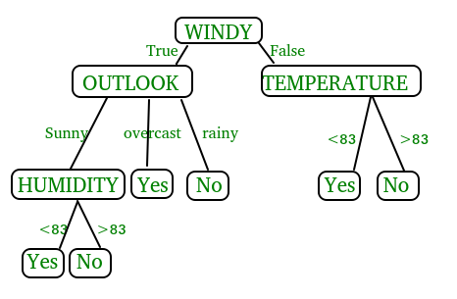

Key Components of Decision Trees in Python
1.Root Node: The decision tree’s starting node, which stands for the complete dataset.
2.Branch Nodes: Internal nodes that represent decision points, where the data is split based on a specific attribute.
3.Leaf Nodes: Final categorization or prediction-representing terminal nodes.
4.Decision Rules: Rules that govern the splitting of data at each branch node.
5.Attribute Selection: The process of choosing the most informative attribute for each split.
6.Splitting Criteria: Metrics like information gain, entropy, or the Gini Index are used to calculate the optimal split.

Assumptions we make while using Decision tree
- At the beginning, we consider the whole training set as the root.
- Attributes are assumed to be categorical for information gain and for gini index, attributes are assumed to be continuous.
- On the basis of attribute values records are distributed recursively.
- We use statistical methods for ordering attributes as root or internal node

Random Forest: Machine learning, a fascinating blend of computer science and statistics, has witnessed incredible progress, with one standout algorithm being the Random Forest. Random forests or Random Decision Trees is a collaborative team of decision trees that work together to provide a single output. Originating in 2001 through Leo Breiman, Random Forest has become a cornerstone for machine learning enthusiasts. In this article, we will explore the fundamentals and implementation of Random Forest Algorithm.
Random Forest algorithm is a powerful tree learning technique in Machine Learning. It works by creating a number of Decision Trees during the training phase. Each tree is constructed using a random subset of the data set to measure a random subset of features in each partition. This randomness introduces variability among individual trees, reducing the risk of overfitting and improving overall prediction performance. In prediction, the algorithm aggregates the results of all trees, either by voting (for classification tasks) or by averaging (for regression tasks) This collaborative decision-making process, supported by multiple trees with their insights, provides an example stable and precise results.
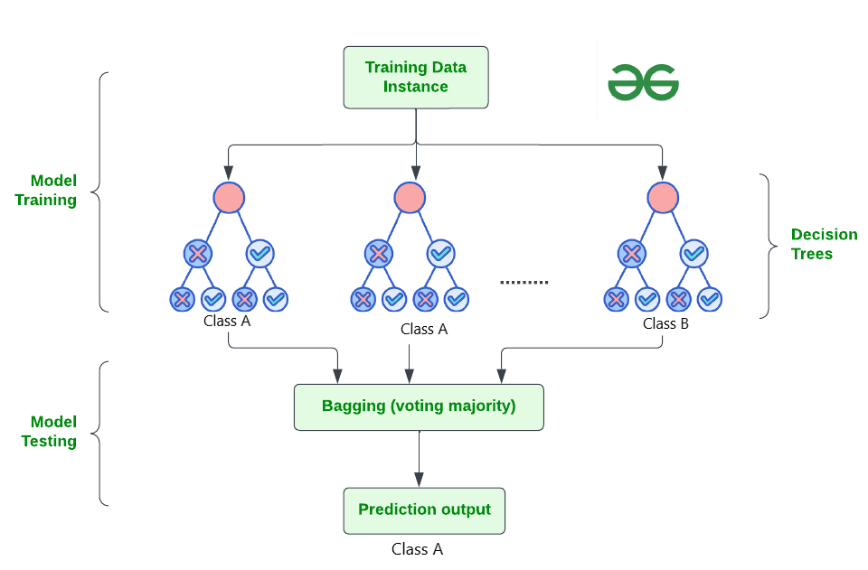

How Does Random Forest Work?
The random Forest algorithm works in several steps which are discussed below
1.Ensemble of Decision Trees: Random Forest leverages the power of ensemble learning by constructing an army of Decision Trees. These trees are like individual experts, each specializing in a particular aspect of the data. Importantly, they operate independently, minimizing the risk of the model being overly influenced by the nuances of a single tree.
2.Random Feature Selection: To ensure that each decision tree in the ensemble brings a unique perspective, Random Forest employs random feature selection. During the training of each tree, a random subset of features is chosen. This randomness ensures that each tree focuses on different aspects of the data, fostering a diverse set of predictors within the ensemble.
3.Bootstrap Aggregating or Bagging: The technique of bagging is a cornerstone of Random Forest’s training strategy which involves creating multiple bootstrap samples from the original dataset, allowing instances to be sampled with replacement. This results in different subsets of data for each decision tree, introducing variability in the training process and making the model more robust.
4.Decision Making and Voting: When it comes to making predictions, each decision tree in the Random Forest casts its vote. For classification tasks, the final prediction is determined by the mode (most frequent prediction) across all the trees. In regression tasks, the average of the individual tree predictions is taken. This internal voting mechanism ensures a balanced and collective decision-making process.
Key Features of Random Forest
Some of the Key Features of Random Forest are discussed below–>
1.High Predictive Accuracy: Imagine Random Forest as a team of decision-making wizards. Each wizard (decision tree) looks at a part of the problem, and together, they weave their insights into a powerful prediction tapestry. This teamwork often results in a more accurate model than what a single wizard could achieve.
2.Resistance to Overfitting: Random Forest is like a cool-headed mentor guiding its apprentices (decision trees). Instead of letting each apprentice memorize every detail of their training, it encourages a more well-rounded understanding. This approach helps prevent getting too caught up with the training data which makes the model less prone to overfitting.
3.Large Datasets Handling: Dealing with a mountain of data? Random Forest tackles it like a seasoned explorer with a team of helpers (decision trees). Each helper takes on a part of the dataset, ensuring that the expedition is not only thorough but also surprisingly quick.
4.Variable Importance Assessment: Think of Random Forest as a detective at a crime scene, figuring out which clues (features) matter the most. It assesses the importance of each clue in solving the case, helping you focus on the key elements that drive predictions.
5.Built-in Cross-Validation: Random Forest is like having a personal coach that keeps you in check. As it trains each decision tree, it also sets aside a secret group of cases (out-of-bag) for testing. This built-in validation ensures your model doesn’t just ace the training but also performs well on new challenges.
6.Handling Missing Values: Life is full of uncertainties, just like datasets with missing values. Random Forest is the friend who adapts to the situation, making predictions using the information available. It doesn’t get flustered by missing pieces; instead, it focuses on what it can confidently tell us.
7.Parallelization for Speed: Random Forest is your time-saving buddy. Picture each decision tree as a worker tackling a piece of a puzzle simultaneously. This parallel approach taps into the power of modern tech, making the whole process faster and more efficient for handling large-scale projects.

Support Vector Machine (SVM):Support Vector Machine (SVM) is a powerful machine learning algorithm used for linear or nonlinear classification, regression, and even outlier detection tasks. SVMs can be used for a variety of tasks, such as text classification, image classification, spam detection, handwriting identification, gene expression analysis, face detection, and anomaly detection. SVMs are adaptable and efficient in a variety of applications because they can manage high-dimensional data and nonlinear relationships. SVM algorithms are very effective as we try to find the maximum separating hyperplane between the different classes available in the target feature. Support Vector Machine (SVM) is a supervised machine learning algorithm used for both classification and regression. Though we say regression problems as well it’s best suited for classification. The main objective of the SVM algorithm is to find the optimal hyperplane in an N-dimensional space that can separate the data points in different classes in the feature space. The hyperplane tries that the margin between the closest points of different classes should be as maximum as possible. The dimension of the hyperplane depends upon the number of features. If the number of input features is two, then the hyperplane is just a line. If the number of input features is three, then the hyperplane becomes a 2-D plane. It becomes difficult to imagine when the number of features exceeds three.
Let’s consider two independent variables x₁, x_{2,} and one dependent variable which is either a blue circle or a red circle.
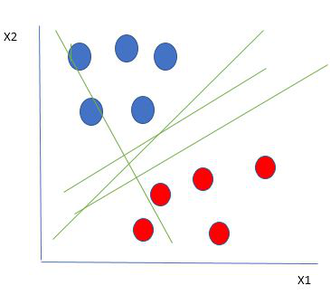
From the figure above it’s very clear that there are multiple lines (our hyperplane here is a line because we are considering only two input features x₁, x₂) that segregate our data points or do a classification between red and blue circles.

Support Vector Machine Terminology

1.Hyperplane: Hyperplane is the decision boundary that is used to separate the data points of different classes in a feature space. In the case of linear classifications, it will be a linear equation i.e. wx+b = 0

2.Support Vectors: Support vectors are the closest data points to the hyperplane, which makes a critical role in deciding the hyperplane and margin.

3.Margin: Margin is the distance between the support vector and hyperplane. The main objective of the support vector machine algorithm is to maximize the margin. The wider margin indicates better classification performance.

4.Kernel: Kernel is the mathematical function, which is used in SVM to map the original input data points into high-dimensional feature spaces, so, that the hyperplane can be easily found out even if the data points are not linearly separable in the original input space. Some of the common kernel functions are linear, polynomial, radial basis function(RBF), and sigmoid.
5.Hard Margin: The maximum-margin hyperplane or the hard margin hyperplane is a hyperplane that properly separates the data points of different categories without any misclassifications.
6.Soft Margin: When the data is not perfectly separable or contains outliers, SVM permits a soft margin technique. Each data point has a slack variable introduced by the soft-margin SVM formulation, which softens the strict margin requirement and permits certain misclassifications or violations. It discovers a compromise between increasing the margin and reducing violations.
Naive Bayes:A Naive Bayes classifier, a family of algorithms based on Bayes’ Theorem. Despite the “naive” assumption of feature independence, these classifiers are widely utilized for their simplicity and efficiency in machine learning. The article delves into theory, implementation, and applications, shedding light on their practical utility despite oversimplified assumptions.

What is Naive Bayes Classifiers?
Naive Bayes classifiers are a collection of classification algorithms based on Bayes’ Theorem. It is not a single algorithm but a family of algorithms where all of them share a common principle, i.e. every pair of features being classified is independent of each other. To start with, let us consider a dataset.
One of the most simple and effective classification algorithms, the Naïve Bayes classifier aids in the rapid development of machine learning models with rapid prediction capabilities.
Naïve Bayes algorithm is used for classification problems. It is highly used in text classification. In text classification tasks, data contains high dimension (as each word represent one feature in the data). It is used in spam filtering, sentiment detection, rating classification etc. The advantage of using naïve Bayes is its speed. It is fast and making prediction is easy with high dimension of data.This model predicts the probability of an instance belongs to a class with a given set of feature value. It is a probabilistic classifier. It is because it assumes that one feature in the model is independent of existence of another feature. In other words, each feature contributes to the predictions with no relation between each other. In real world, this condition satisfies rarely. It uses Bayes theorem in the algorithm for training and prediction

Why it is Called Naive Bayes?
The “Naive” part of the name indicates the simplifying assumption made by the Naïve Bayes classifier. The classifier assumes that the features used to describe an observation are conditionally independent, given the class label. The “Bayes” part of the name refers to Reverend Thomas Bayes, an 18th-century statistician and theologian who formulated Bayes’ theorem.
Consider a fictional dataset that describes the weather conditions for playing a game of golf. Given the weather conditions, each tuple classifies the conditions as fit(“Yes”) or unfit(“No”) for playing golf.Here is a tabular representation of our dataset.
The assumptions made by Naive Bayes are not generally correct in real-world situations. In-fact, the independence assumption is never correct but often works well in practice.Now, before moving to the formula for Naive Bayes, it is important to know about Bayes’ theorem.

Bayes’ Theorem
Bayes’ Theorem finds the probability of an event occurring given the probability of another event that has already occurred. Bayes’ theorem is stated mathematically as the following equation:
P(A∣B)=P(B)P(B∣A)P(A)​
where A and B are events and P(B) ≠ 0
- Basically, we are trying to find probability of event A, given the event B is true. Event B is also termed as evidence.
- P(A) is the priori of A (the prior probability, i.e. Probability of event before evidence is seen). The evidence is an attribute value of an unknown instance(here, it is event B).
- P(B) is Marginal Probability: Probability of Evidence.
- P(A|B) is a posteriori probability of B, i.e. probability of event after evidence is seen.
- P(B|A) is Likelihood probability i.e the likelihood that a hypothesis will come true based on the evidence.

CHAPTER 06
IMPLEMENTATION

6.1 SAMPLE CODE
from tkinter import messagebox
from tkinter import *
from tkinter import simpledialog
import tkinter
from tkinter import filedialog
from tkinter.filedialog import askopenfilename
import numpy as np
import matplotlib.pyplot as plt
import pandas as pd
from sklearn.preprocessing import normalize
from sklearn.metrics import accuracy_score
from sklearn.model_selection import train_test_split
import os
from sklearn.metrics import confusion_matrix
from sklearn.metrics import accuracy_score
from sklearn.tree import DecisionTreeClassifier
from sklearn.naive_bayes import GaussianNB
from sklearn import svm
from sklearn.metrics import precision_score
from sklearn.metrics import recall_score
from sklearn.metrics import f1_score
import seaborn as sns
import webbrowser
from sklearn.ensemble import RandomForestClassifier
from sklearn.linear_model import LogisticRegression
from sklearn.neural_network import MLPClassifier
from sklearn.ensemble import AdaBoostClassifier
from keras.utils.np_utils import to_categorical
from keras.layers import MaxPooling2D
from keras.layers import Dense, Dropout, Activation, Flatten
from keras.layers import Convolution2D
from keras.models import Sequential
from keras.models import model_from_json
import pickle
global filename
global X,Y
global dataset
global main
global text
accuracy = []
precision = []
recall = []
fscore = []
global X_train, X_test, y_train, y_test, predict_cls
global classifier
main = tkinter.Tk()
main.title("Comparative Study of Machine Learning Algorithms for Fraud Detection in Blockchain") #designing main screen
main.geometry("1300x1200")
#fucntion to upload dataset
def uploadDataset():
global filename
global dataset
text.delete('1.0', END)
filename = filedialog.askopenfilename(initialdir="Dataset")
text.insert(END,filename+" loaded\n\n")
dataset = pd.read_csv(filename)
text.insert(END,"Dataset before preprocessing\n\n")
text.insert(END,str(dataset.head()))
text.update_idletasks()
label = dataset.groupby('FLAG').size()
label.plot(kind="bar")
plt.title("Blockchain Fraud Detection Graph 0 means Normal & 1 means Fraud")
plt.show()
#function to perform dataset preprocessing
def trainTest():
global X,Y
global dataset
global X_train, X_test, y_train, y_test
text.delete('1.0', END)
#replace missing values with 0
dataset.fillna(0, inplace = True)
Y = dataset['FLAG'].ravel()
dataset = dataset.values
X = dataset[:,4:dataset.shape[1]-2]
X = normalize(X)
indices = np.arange(X.shape[0])
np.random.shuffle(indices)
X = X[indices]
Y = Y[indices]
X = X[0:5000]
Y = Y[0:5000]
print(Y)
print(X)
text.insert(END,"Dataset after features normalization\n\n")
text.insert(END,str(X)+"\n\n")
text.insert(END,"Total records found in dataset : "+str(X.shape[0])+"\n")
text.insert(END,"Total features found in dataset: "+str(X.shape[1])+"\n\n")
X_train, X_test, y_train, y_test = train_test_split(X, Y, test_size=0.2)
def calculateMetrics(algorithm, predict, y_test):
a = accuracy_score(y_test,predict)*100
p = precision_score(y_test, predict,average='macro') * 100
r = recall_score(y_test, predict,average='macro') * 100
f = f1_score(y_test, predict,average='macro') * 100
accuracy.append(a)
precision.append(p)
recall.append(r)
fscore.append(f)
text.insert(END,algorithm+" Accuracy : "+str(a)+"\n")
text.insert(END,algorithm+" Precision : "+str(p)+"\n")
text.insert(END,algorithm+" Recall : "+str(r)+"\n")
text.insert(END,algorithm+" FScore : "+str(f)+"\n\n")
def runLogisticRegression():
global X,Y, X_train, X_test, y_train, y_test
global accuracy, precision,recall, fscore
accuracy.clear()
precision.clear()
recall.clear()
fscore.clear()
text.delete('1.0', END)
lr = LogisticRegression()
lr.fit(X, Y)
predict = lr.predict(X_test)
calculateMetrics("Logistic Regression", predict, y_test)
def runMLP():
mlp = MLPClassifier()
mlp.fit(X_train, y_train)
predict = mlp.predict(X_test)
calculateMetrics("MLP", predict, y_test)
def runNaiveBayes():
cls = GaussianNB()
cls.fit(X_train, y_train)
predict = cls.predict(X_test)
calculateMetrics("Naive Bayes", predict, y_test)
def runAdaBoost():
cls = AdaBoostClassifier()
cls.fit(X_train, y_train)
predict = cls.predict(X_test)
calculateMetrics("AdaBoost", predict, y_test)
def runDT():
global predict_cls
cls = DecisionTreeClassifier()
cls.fit(X_train, y_train)
predict = cls.predict(X_test)
calculateMetrics("Decision Tree", predict, y_test)
def runSVM():
cls = svm.SVC()
cls.fit(X_train, y_train)
predict = cls.predict(X_test)
calculateMetrics("SVM", predict, y_test)
def runRF():
global predict_cls
rf = RandomForestClassifier()
rf.fit(X_train, y_train)
predict = rf.predict(X_test)
predict_cls = rf
calculateMetrics("Random Forest", predict, y_test)
def predict():
global predict_cls
text.delete('1.0', END)
filename = filedialog.askopenfilename(initialdir="Dataset")
dataset = pd.read_csv(filename)
dataset.fillna(0, inplace = True)
dataset = dataset.values
X = dataset[:,4:dataset.shape[1]-2]
X1 = normalize(X)
prediction = predict_cls.predict(X1)
print(prediction)
for i in range(len(prediction)):
if prediction[i] == 0:
text.insert(END,"Test DATA : "+str(X[i])+" ===> PREDICTED AS NORMAL\n\n")
else:
text.insert(END,"Test DATA : "+str(X[i])+" ===> PREDICTED AS FRAUD\n\n")
def graph():
output = "<html><body><table align=center border=1><tr><th>Algorithm Name</th><th>Accuracy</th><th>Precision</th><th>Recall</th>"
output+="<th>FSCORE</th></tr>"
output+="<tr><td>Logistic Regression Algorithm</td><td>"+str(accuracy[0])+"</td><td>"+str(precision[0])+"</td><td>"+str(recall[0])+"</td><td>"+str(fscore[0])+"</td></tr>"
output+="<tr><td>Naive Bayes Algorithm</td><td>"+str(accuracy[2])+"</td><td>"+str(precision[2])+"</td><td>"+str(recall[2])+"</td><td>"+str(fscore[2])+"</td></tr>"
output+="<tr><td>AdaBoost Algorithm</td><td>"+str(accuracy[3])+"</td><td>"+str(precision[3])+"</td><td>"+str(recall[3])+"</td><td>"+str(fscore[3])+"</td></tr>"
output+="</table></body></html>"
f = open("table.html", "w")
f.write(output)
f.close()
webbrowser.open("table.html",new=2)
df=pd.DataFrame([['LogisticRegression','Precision',precision[0]],['Logistic Regression','Recall',recall[0]],['Logistic Regression','F1 Score',fscore[0]],['Logistic Regression','Accuracy',accuracy[0]],
['MLP','Precision',precision[1]],['MLP','Recall',recall[1]],['MLP','F1 Score',fscore[1]],['MLP','Accuracy',accuracy[1]],
['naïveBayes','Precision',precision[2]],['NaiveBayes','Recall',recall[2]],['NaiveBayes','F1 Score',fscore[2]],['Naive Bayes','Accuracy',accuracy[2]],
['AdaBoost','Precision',precision[3]],['AdaBoost','Recall',recall[3]],['AdaBoost','F1 Score',fscore[3]],['AdaBoost','Accuracy',accuracy[3]],
['DecisionTree','Precision',precision[4]],['DecisionTree','Recall',recall[4]],['DecisionTree','F1Score',fscore[4]],['Decision Tree','Accuracy',accuracy[4]],
['SVM','Precision',precision[5]],['SVM','Recall',recall[5]],['SVM','F1 Score',fscore[5]],['SVM','Accuracy',accuracy[5]],
['RandomForest','Precision',precision[6]],['RandomForest','Recall',recall[6]],['Random Forest','F1 Score',fscore[6]],['Random Forest','Accuracy',accuracy[6]],
['DeepNeuralNetwork','Precision',precision[7]],['DeepNeuralNetwork','Recall',recall[7]],['DeepNeuralNetwork','F1Score',fscore[7]],['DeepNeuralNetwork','Accuracy',accuracy[7]],
plt.show()
font = ('times', 16, 'bold')
title = Label(main, text='Comparative Study of Machine Learning Algorithms for Fraud Detection in Blockchain')
title.config(bg='greenyellow', fg='dodger blue')
title.config(font=font)
title.config(height=3, width=120)
title.place(x=0,y=5)
font1 = ('times', 12, 'bold')
text=Text(main,height=20,width=150)
scroll=Scrollbar(text)
text.configure(yscrollcommand=scroll.set)
text.place(x=50,y=120)
text.config(font=font1)
font1 = ('times', 13, 'bold')
uploadButton = Button(main, text="Upload & Preprocess Dataset", command=uploadDataset)
uploadButton.place(x=50,y=550)
uploadButton.config(font=font1)
traintestButton = Button(main, text="Generate Train & Test Model", command=trainTest)
traintestButton.place(x=330,y=550)
traintestButton.config(font=font1)
lrButton = Button(main, text="Run Logistic Regression Algorithm", command=runLogisticRegression)
lrButton.place(x=630,y=550)
lrButton.config(font=font1)
mlpButton = Button(main, text="Run MLP Algorithm", command=runMLP)
mlpButton.place(x=950,y=550)
mlpButton.config(font=font1)
nbButton = Button(main, text="Run Naive Bayes Algorithm", command=runNaiveBayes)
nbButton.place(x=50,y=600)
adaboostButton = Button(main, text="Run AdaBoost Algorithm", command=runAdaBoost)
adaboostButton.place(x=330,y=600)
dtButton = Button(main, text="Run Decision Tree Algorithm", command=runDT)
dtButton.place(x=630,y=600)
dtButton.config(font=font1)
svmButton = Button(main, text="Run SVM Algorithm", command=runSVM)
svmButton.place(x=950,y=600)
svmButton.config(font=font1)
rfButton = Button(main, text="Run Random Forest Algorithm", command=runRF)
rfButton.place(x=50,y=650)
rfButton.config(font=font1)
dnButton = Button(main, text="Run Deep Network Algorithm", command=runDeepNetwork)
dnButton.place(x=330,y=650)
dnButton.config(font=font1)
graphButton = Button(main, text="Comparison Graph", command=graph)
graphButton.place(x=630,y=650)
graphButton.config(font=font1)
predictButton = Button(main, text="Predict Fraud ", command=predict)
predictButton.place(x=950,y=650)
predictButton.config(font=font1)
main.config(bg='LightSkyBlue')
main.mainloop()

CHAPTER 07
TESTING

7.1 SYSTEM TESTING
Testing has become an integral part of any system or project especially in the field of information technology. The importance of testing is a method of justifying, if one is ready to move further, be it to be check if one is capable to with stand the rigors of a particular situation cannot be underplayed and that is why testing before development is so critical. When the software is developed before it is given to user to use the software must be tested whether it is solving the purpose for which it is developed. This testing involves various types through which one can ensure the software is reliable. The program was tested logically and pattern of execution of the program for a set of data are repeated. Thus the code was exhaustively checked for all possible correct data and the outcomes were also checked.
7.2 MODULE TESTING
To locate errors, each module is tested individually. This enables us to detect error and correct it without affecting any other modules. Whenever the program is not satisfying the required function, it must be corrected to get the required result. Thus all the modules are individually tested from bottom up starting with the smallest and lowest modules and proceeding to the next level. Each module in the system is tested separately. For example the job classification module is tested separately. This module is tested with different job and its approximate execution time and the result of the test is compared with the results that are prepared manually. The comparison shows that the results proposed system works efficiently than the existing system. Each module in the system is tested separately. In this system the resource classification and job scheduling modules are tested separately and their corresponding results are obtained which reduces the process waiting time.

7.3 INTEGRATION TESTING
After the module testing, the integration testing is applied. When linking the modules there may be chance for errors to occur, these errors are corrected by using this testing. In this system all modules are connected and tested. The testing results are very correct. Thus the mapping of jobs with resources is done correctly by the system.

7.4 ACCEPTANCE TESTING
When that user fined no major problems with its accuracy, the system passers through a final acceptance test. This test confirms that the system needs the original goals, objectives and requirements established during analysis without actual execution which elimination wastage of time and money acceptance tests on the shoulders of users and management, it is finally acceptable and ready for the operation.

Test Case Id | Test Case Name | Test Case Desc. | Test Steps |  |  | Test Case Status | Test Priority
 |  |  | Step | Expected | Actual
01 | upload & preprocess dataset | Verify upload & preprocess dataset or not | If Dataset may not upload | we cannot do any further operations | we can do further operations | High | High
02 | generate Train& test model | Verify generate Train& test model | If verifiy may not compute | we cannot do any further operations | we can do further operations | High | High
03 | run logistic algorithm | Verify run logistic algorithm or not | If run logistic algorithm may not be Run | we cannot do any further operations | we can do further operations | High | High
04 | run MLP algorithm | Verify Run MLP algorithm or not | If MLP may not Run | We cannot run operation | We can Run the Operation | High | High
05 | run naive bayes algorithm | Verify run naive bayes algorithm or not | If run naive bayes algorithm may not plot | We cannot run  operation | We can Run the Operation | High | High
06 | run ad boost algorithm | Verify ad boost algorithm or not | If run ada boost algorithm may not plot | We cannot run  operation | We can Run the Operation | High | high
07 | run decision tree algorithm | Verify decision tree algorithm or not | If run decision tree algorithm may not plot | We cannot run  operation | We can Run the Operation | high | High
08 | run svm algorithm | Verify SVM algorithm or not | If SVM algorithm may not plot | We cannot run  operation | We can Run the Operation | High | High
09 | run random forest algorithm | Verify random forest algorithm or not | If run random forest algorithm may not plot | We cannot run  operation | We can Run the Operation | High | High
10 | run deep Network algorithm | Verify deep Network algorithm or not | If run deep Network algorithm may not plot | We cannot run  operation | We can Run the Operation | High | High
11 | comparison graph | Verify the comparison graph or not | If comparison graph may not plot | We cannot run operation | We can run operation | High | High

CHAPTER 08
RESULTS

8.1 RESULTS

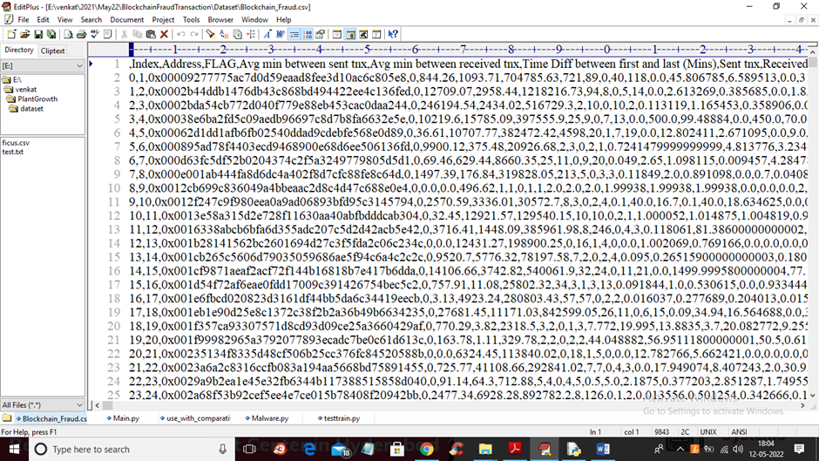

FIG 8.1.1 TEST DATASET

In above screen first row contains dataset column names and remaining rows contains dataset values.

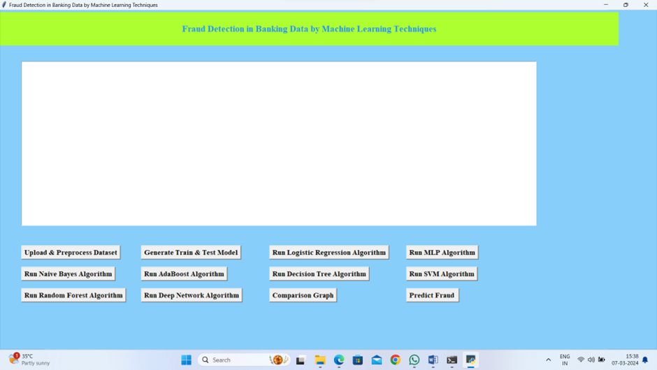

FIG 8.1.2 DATASET VALUES

To run project double click on ‘run.bat’ file to get below screen
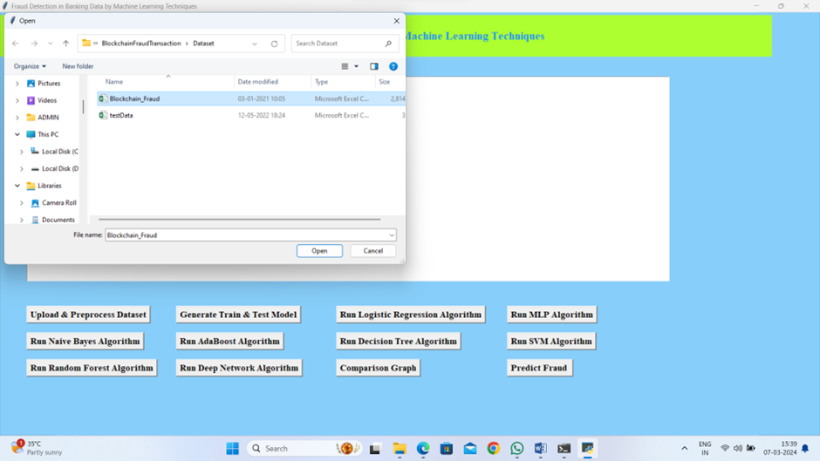

FIG 8.1.3 UPLOAD & PREPROCESS DATA

In above screen click on ‘Upload & Preprocess Dataset’ button to upload and read dataset and then remove missing values

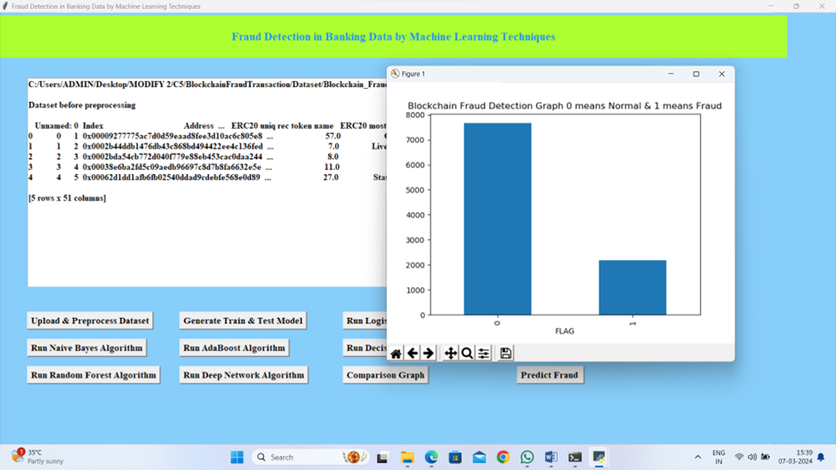

FIG 8.1.4 UPLOADED DATA

In above screen selecting and uploading dataset and then click on ‘Open’ button to load dataset and get below output

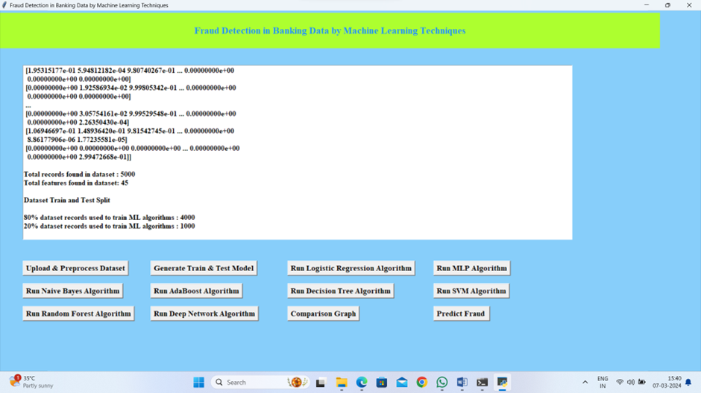

FIG 8.1.5 LOGISTIC REGRESSION ALGORITHM

In above screen dataset loaded and dataset contains some non-numeric data and ML algorithms will not take such data so we need to remove and graph x-axis contains type of transaction and y-axis contains number of records and now close above graph and then click on‘Generate Train & Test Model’ button to get below output

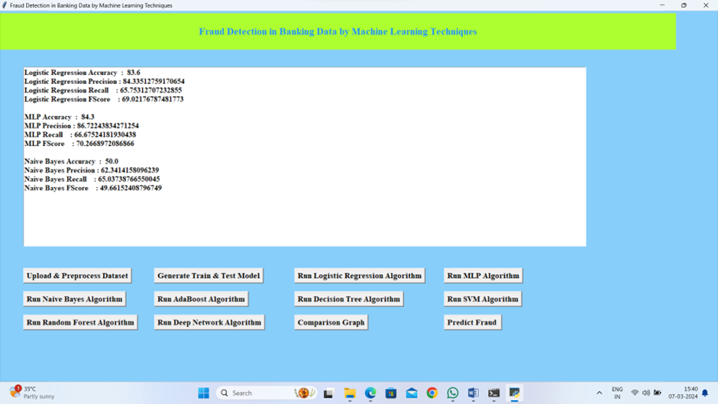

FIG 8.1.6 MLP & NAIVE BAYES ALGORITHM

In above screen we can see all data converted to numeric format and we can see total records found in dataset with total columns and then split dataset into train and test and now train and test data is ready and now click on each button to run all algorithms and get below output

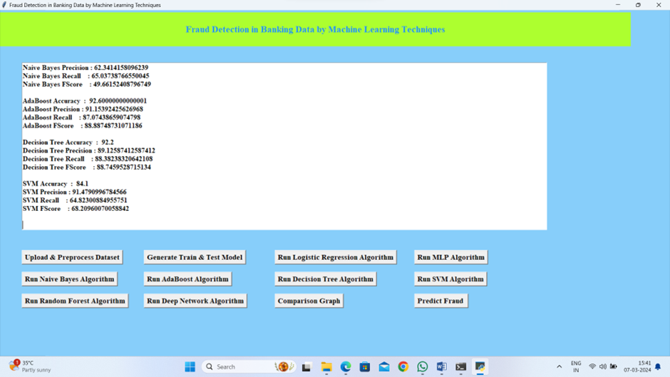

FIG 8.1.7 DECISION TREE & SVM ALGORITHM

In above screen we can see the performance or accuracy of each algorithm and below is the remaining algorithm accuracy

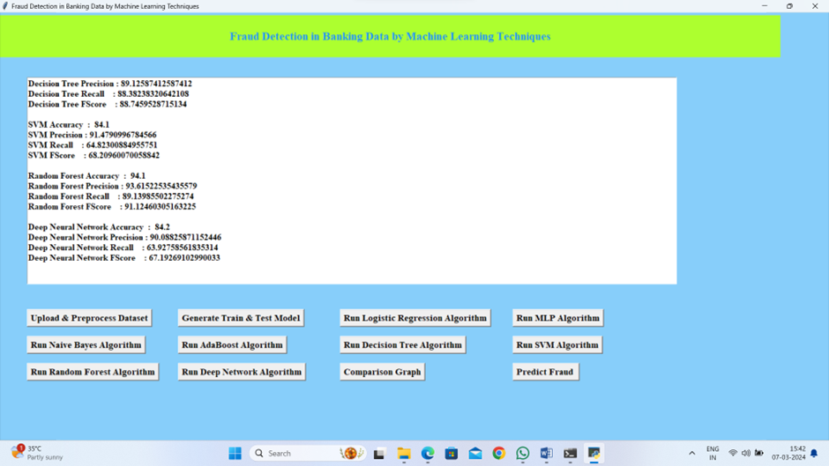

FIG 8.1.8 RANDOM FOREST & DNN ALGORITHM

In above screen we can see accuracy of AdaBoost, Decision Tree and SVM and below is the accuracy of remaining algorithms

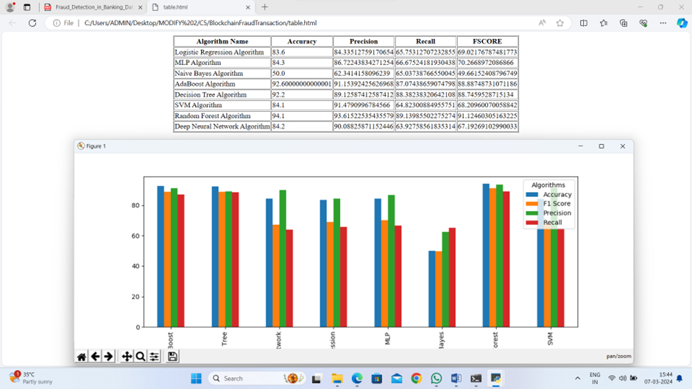

FIG 8.1.9 COMPARISION GRAPH

In above screen we can see the accuracy, precision, recall and FSCORE of each algorithm in graph and tabular format and in all algorithms Random Forest giving better result

CHAPTER 09
CONCLUSION

9.1 CONCLUSION
This project introduced blockchain technology and its defining characteristics. They also review state-of-the-art technologies for detecting online fraud and intrusions, identify certain fraud and malicious activities that blockchain technology can effectively prevent, and make recommendations for strategically fighting various attacks to which blockchain technology may be vulnerable. Existing machine learning and data-mining algorithms could find new uses in identifying fraud and intrusions in blockchain-based transactions. Guided machine learning methods like deep-learning neural networks, support vector machines, and Bayesian belief networks may help detect outlier behaviors by profiling, monitoring, and detecting behavioral trends based on people's transaction histories. Despite the advancement in technology, still, the problems regarding Video Fraudulence are faced and there is no concrete solution for this problem. To improve the technology and related anti-attack methods, more research is required.

CHAPTER 10
FUTURE ENHANCEMENT

10.1 FUTURE ENHANCEMENTS

- Data quality improvement: Collect and integrate more diverse and high-quality data to improve model accuracy.
- Model ensemble: Combine multiple machine learning models to enhance detection capabilities.
- Multi- modal analysis: Integrate multiple data sources, such as transaction history, user behavior, and device information.
- Adaptive learning: Develop models that can adapt to evolving fraud patterns and stay up-to-date with new types of fraud.
- Graph based analysis: Use graph-based methods to detect complex networks of fraudulent activities
- Credit card fraud detection: Develop systems to detect fraudulent credit card transactions.
- Account takeover detection: Identify and prevent account takeover attempts.
- Money laundering detection: Detect suspicious patterns indicative of money laundering.

CHAPTER 11-
REFERENCE

11.1 REFERENCES
1.Dhiran, A., Kumar, D., & Arora, A. (2020, July). Video Fraud Detection using blockchain. In 2020 Second International Conference on Inventive Research in Computing Applications (ICIRCA) (pp. 102-107). IEEE.
2.Ostapowicz, M., & Żbikowski, K. (2020, January). Detecting fraudulent accounts on blockchain: a supervised approach. In International Conference on Web Information Systems Engineering (pp. 18-31). Springer, Cham.
3.Nerurkar P, Bhirud S, Patel D, Ludinard R, Busnel Y, Kumari S. Supervised learning model for identifying illegal activities in Bitcoin. Appl Intell. 2020;209(1):1- 20.
4.Dhieb, N., Ghazzai, H., Besbes, H., & Massoud, Y. (2020). A secure ai-driven architecture for automated insurance systems: Fraud detection and risk measurement. IEEE Access, 8, 58546-58558.
5.Joshi, P., Kumar, S., Kumar, D., & Singh, A. K. (2019, September). A blockchain based framework for fraud detection. In 2019 Conference on Next Generation Computing Applications (NextComp) (pp. 1-5). IEEE.
6.Raikwar, M., Mazumdar, S., Ruj, S., Gupta, S. S., Chattopadhyay, A., & Lam, K. Y. (2018, February). A blockchain framework for insurance processes. In 2018 9th IFIP International Conference on New Technologies, Mobility and Security (NTMS) (pp. 1-4). IEEE.
7.Cai, Y., & Zhu, D. (2016). Fraud detections for online businesses: a perspective from blockchain technology. Financial Innovation, 2(1), 1-10.
8.Shanmuga Priya P and Swetha N, “Online Certificate Validation using Blockchain”, Special Issue Published in Int. Jnl. Of Advanced Networking and Applications (IJANA).
9.Monamo, P. M., Marivate, V., & Twala, B. (2016, December). A multifaceted approach to bitcoin fraud detection: Global and local outliers. In 2016 15th IEEE International Conference on Machine Learning and Applications (ICMLA) (pp. 188-194). IEEE.
10.Xu, J. J. (2016). Are blockchains immune to all malicious attacks? Financial Innovation, 2(1), 1-9. [11] M. Young, The Technical Writer’s Handbook. Mill Valley, CA: University Science, 1989.
11.R. Nicole, “Title of paper with only first word capitalized,” J. Name Stand. Abbrev., in press.

